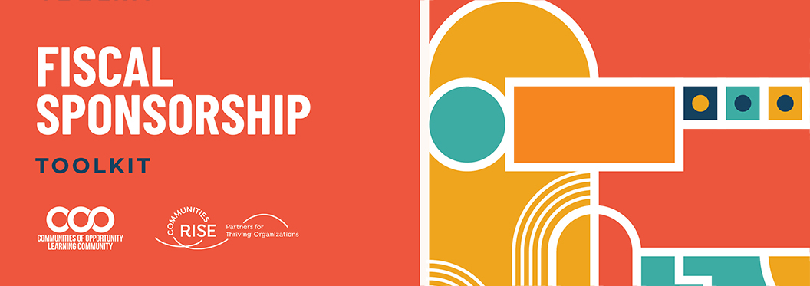

Instructions To Use Statement of Shared Values Template

The following Statement of Shared Values Template (Template) is designed to be used by nonprofits for who are entering into a fiscal sponsorship relationship. This Template provides an example of a written document that captures your shared values, agreed upon communication norms, and ways of dealing with conflict. It provides a format for the parties to have a discussion about these topics. This is a tool and should be edited or changed to support your work together. It is not legally binding or necessary. We have included some things to consider when drafting this document below.

Things to Consider on Setting Shared Values
Invest enough time and other resources as needed to determine core areas of alignment for this collaborative relationship - including key values and how your collaboration will navigate conflict.
The following questions about values may be helpful for the Sponsored Organization and Sponsor to discuss together:
- What are the key values that we need to share to achieve our common goal?
- How will we practice or operationalize these values in our work and the way we collaborate as partners?”

Things to Consider about Communication Norms
The ability to communicate your needs and respond to the other party’s inquiries clearly and promptly is key to any meaningful and productive relationship. Similar to wanting a mutual understanding about values or conflict resolution, both sides of the fiscal sponsorship relationship will want to be understood and responded to promptly. To accomplish strong communication, it is a best practice to discuss communication norms before you begin their work together.
The following questions about communication may be helpful for the Sponsored Organization and Sponsor to discuss together:
- What modes of communication do the parties use and favor (email, text, phone, video call, slack)?
- How often do you want to check in or have regular discussions about finances or other matters?
- What is the expected response time for inquiries by email, phone, text or slack?
- What is the expected response time for payment/check requests?
- Who is the person with contact information to contact for different types of inquiries such as: financial, employment, fundraising, etc?

Things to Consider about Conflict Management
Conflict is natural and will occur in every relationship - including fiscal sponsorships. Conflict is often viewed as negative and destructive, but it can actually be a generative opportunity to more deeply understand one another, to strengthen relationships, and to work together to identify creative new solutions that might not have been considered before. However, generative conflict is only possible through proactive, open, and honest communication about conflict before it actually arises. This includes conversations, skill-building, and forming group agreements around issues such as:
- What experiences, norms, and values do the Sponsored Organization and Sponsor hold around conflict?
- What is the Sponsored Organization’s and Sponsor’s default response to conflict? Increasing self-awareness of our default responses, as well as learning about each other’s responses, can help to defuse tension and miscommunication and helps us choose our response.
- What does your collaborative relationship between Sponsored Organization and Sponsor need to have alignment around in order to achieve its purpose and what does it not need to have alignment on?
- What approaches or practices would your collaborative relationship like to turn to when conflict arises? Are there cultural or identified practices for the collaboration between Sponsor and Sponsored Organization like restorative justice circles or designated trusted advisors in the community that the group wants to consult?

The Template can be used as follows:
- All yellow highlighted text is to be filled out with customized information for the particular parties and collaboration.
- All blue highlighted text and bracketed text are comments or notes to assist in completing that particular section. Please delete the entire bracketed blue text after reading comments/notes.

[IMPORTANT NOTE: This is a template that is intended to provide the basic terms of a fiscal sponsorship agreement. Every fiscal sponsorship project will need to customize this document, which may require deleting some of the provisions included here or adding provisions that are not included. Please think carefully about what is important to the parties to the agreement and the goals of the fiscal sponsorship, to make sure that the important aspects of your fiscal sponsorship are included in your agreement.

DISCLAIMER: This Agreement Template is for educational purposes only. This is not meant to be comprehensive, and in no way will this content be considered legal or any other form of professional advice or counsel. For legal or professional advice, please contact the relevant professional for your needs licensed in your jurisdiction.]

Fiscal Sponsorship Statement of Shared Values

This document holds our mutual commitment to working together and building a trust and respect-based fiscal sponsorship relationship. We have come together to further the missions of our respective organizations. We see the value of our work together for our communities.

Shared Values

[Examples include the following…]
- Trust - short description of what this means to both orgs
- Respect
- Racial Equity
- Social Justice

Communication Norms

[Examples of potential language or considerations…]
- Respond to email or slack communication with 5 work days]
- We agree to communicate by email at the following email addresses: name@org.org and name@org.org.]
- Each of us will respond to electronic inquiries within x# days.

Conflict Resolution

[Examples of potential language or considerations…]
- If we find ourselves in conflict, we will prioritize acting in a way that is aligned with our Shared Values (listed above).
- We will refer to our Fiscal Sponsorship Agreement to see if we had made a previous relevant agreement on the topic of conflict.
- We will work with a facilitator to help us come together with a new perspective. ]

_____________________. _____________________________-
Name: [Name] Name: [Name]
Org: [Org Name] Org: [Org Name]
Date: [Date} Date: [Date}

